Miranda Llewellyn

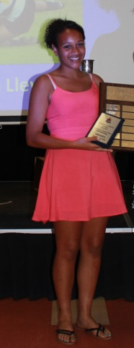
Miranda is a talented athlete who has been a valuable contributor to Belmont's soccer, rugby and basketball programs the past three years. She is an intense competitor on the field or court, but never loses her composure and always displays exemplary sportsmanship. Soccer was Miranda’s #1 sport growing up, and she captained her Juan de Fuca club team to three straight District cups. At the school level, she played on the senior team as a grade 10 and was a member of the Belmont squad that won the league title in 2013 and advanced to the BC Championship tournament the following year.
Although short in stature, Miranda’s speed, strength and tenacity made her a natural for rugby, and after taking up the game with the Castaways community team in middle school, she improved rapidly. In 2013, she was named to the U-16 Team B.C. girls’ rugby team and represented her province in a number of competitions. She also became an anchor of Belmont’s rugby team and helped the Bulldogs win a city championship and advance to the provincial tournament for the first time in the school’s history. In basketball, Miranda played guard on the Belmont junior girls’ group that finished 4th on the Island in 2013, and after a year’s hiatus, returned to the sport again her senior year.
All Miranda’s coaches describe her in glowing terms: as an athlete who always gives 100% effort in practices and games, is respectful to opponents and officials, and is fully supportive of her team-mates. She was a popular choice as co-winner of Belmont’s junior sportsmanship award in 2013 and took home the senior girls’ sportsmanship trophy in 2015. She is also a dedicated student and three times earned scholar-athlete certificates for maintaining an “A” average in her classes while playing on multiple school sports teams.
Miranda interviewed a number of our Hall of Fame athletes and produced their written profiles. When asked about her experience with the sports history project, Miranda responded, “It was so interesting hearing their stories and it gave insight into what my future might hold. Even if you no longer play sports at a high level, sports can continue to play a huge role in your life.”

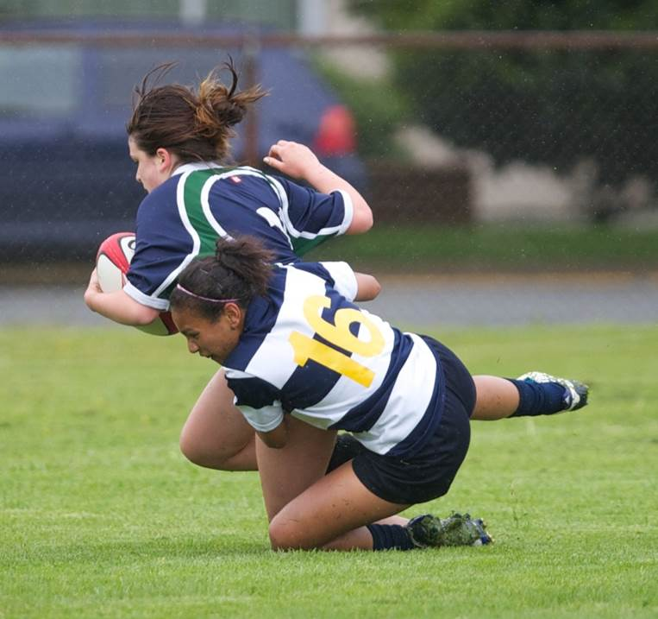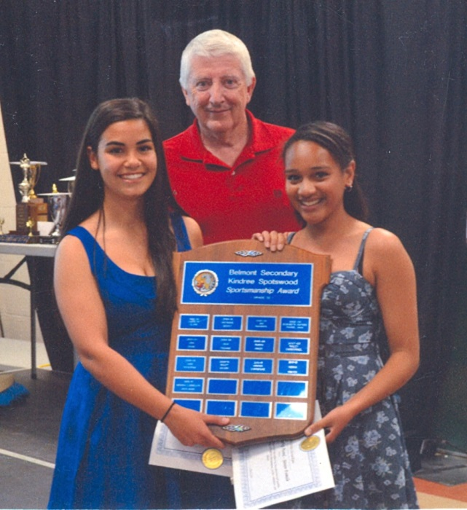
Miranda brings down an opponent with a classic tackle during a high school rugby match
Miranda (on the right) and co-winner Julia Muniz accept the junior girls’ sportsmanship trophy from soccer coach Lloyd Powell

