Michelle Bainbridge O’Regan: 1987-1989
Michelle Bainbridge was a multi-sport athlete who excelled at cross country, track and field, soccer and field hockey during her two years at Belmont. She also ran track, played Langford fastball and Juan de Fuca soccer in the community. Michelle helped a number of Belmont teams qualify for Island and provincial championships in grade 11 and 12. She was a member of the 1987-88 girls’ soccer team that won the Lower Island and Island titles and finished 4th in the province. One year later, the same nucleus of girls did even better, winning the bronze medals at the BC championship tournament. She was also a key member of the cross country and track teams, excelling at the middle distance events. Michelle has fond memories of “training and competing with a great group of athletes and teacher coaches, and traveling to sporting events around the city, island and province.”
Athletics continued to play a central role in Michelle’s life after high school graduation, and she was recruited to run cross country and track for the University of Victoria’s varsity team, competing at meets all over Canada and the U.S.A. She was part of the group that won the CWUAA (Canada West) team championship at UBC and captured the CIAU national title in London, Ontario in 1994. Individually, she placed 5th in Canada West competition and 15th in Canada. She made the varsity cross country and indoor/outdoor track teams for all five of her years at Uvic. She also continued to play women’s soccer and ran some longer races after university, including 10 km, ½ and full marathons. She went on to get married and have three daughters and she has coached their soccer teams at various levels through the Lakehill organization.
Michelle says that there were several coaches who helped her along the way. Mrs. M. Hewson was instrumental in encouraging her to take up running in grade 8, and Peter Songhurst, Gary Mols and Muzz Bryant all provided support along the way. At Uvic, her coach Ron Bowker was a very positive influence.
Michelle’s advice to current Belmont athletes is to “Stay active, join as much as you can, be involved in your school and community. Take full advantage of your high school experience and join as many teams and clubs as possible. Be a good ambassador for your school by demonstrating fair play, sportsmanship, and be a strong competitor.”
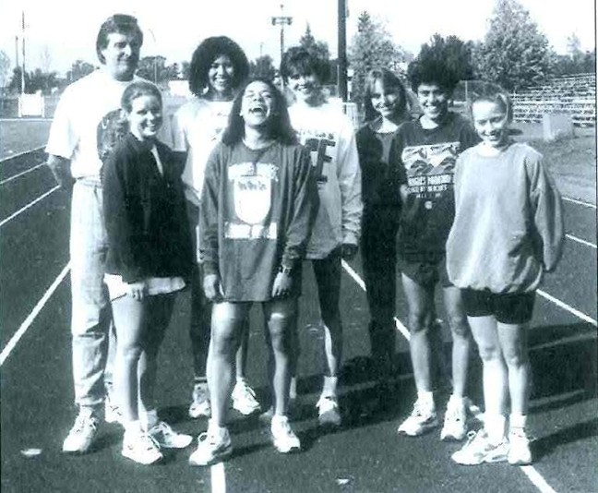
Michelle is standing on the far left with her Uvic team-mates and coach Ron Bowker after their team won the 1994 Canadian cross country championship

