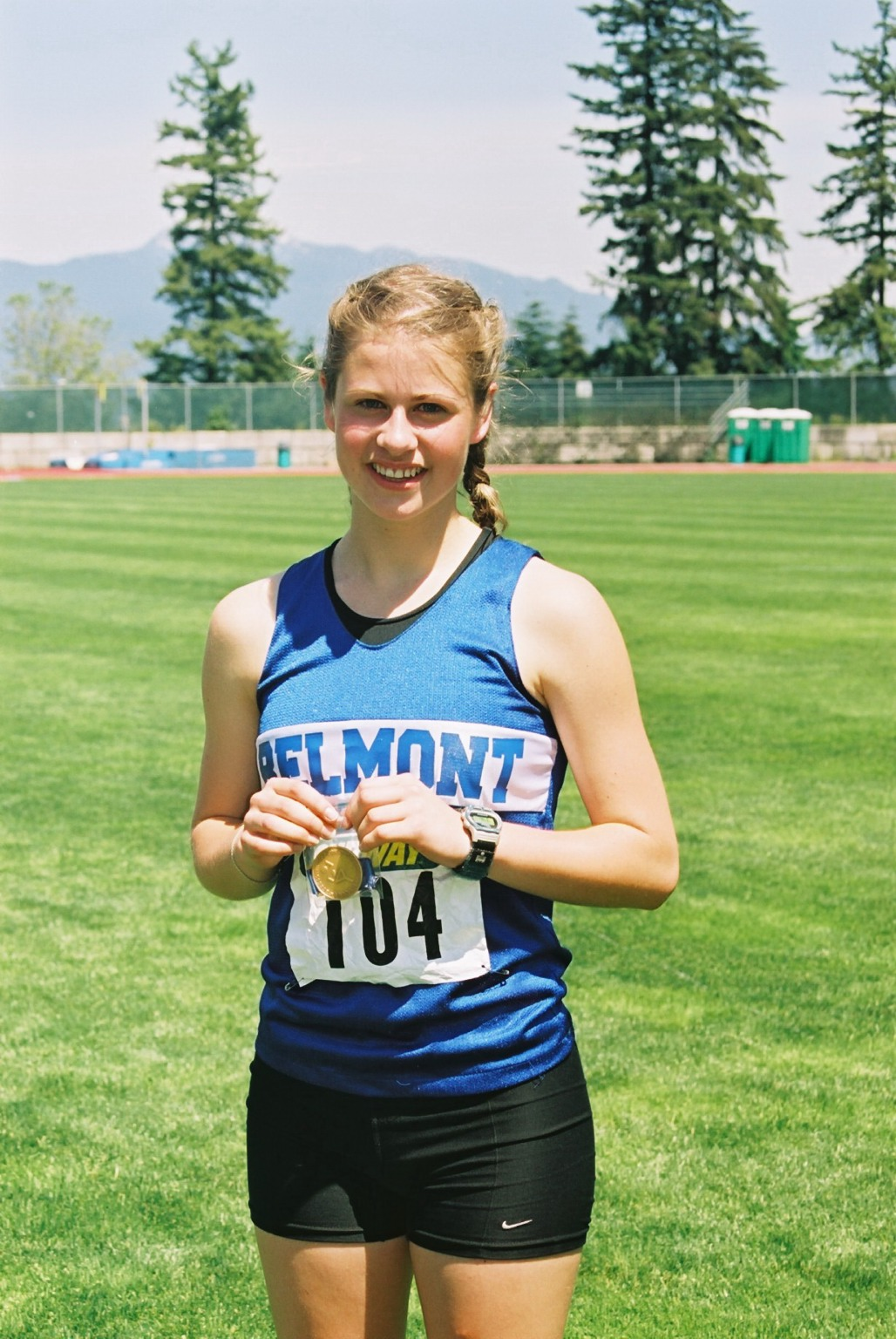
Megan Huzzey: 2000-2003

Megan, winner of Belmont’s top athlete award in grade 10, 11 and 12, she participated in cross country, track and field and soccer, but it was in the racewalk event that she attained national prominence. She captured the BC high school title for three consecutive years in the 1500 meter racewalk, and the record she set in 2003 as a grade 12 student remains unbroken today. Despite the accolades she received for her individual accomplishments, Megan says her best Belmont sporting memory was of the 4x400 meter relay team she put together in grade 12 with her sister Kaitlin Huzzey and two close friends Melissa Klein and Patricia Roney. The group finished third on the Island and went on to represent Belmont at provincials. Although the team didn’t reach the podium, according to Megan, they had “a blast running fast.”

After high school graduation, Megan attended UBC on an athletic scholarship and competed for the varsity Cross Country and Track & Field teams from 2003-2008. She won the 3000m racewalk at the NAIA national championship title an incredible four times, and also competed for Team Canada at the World Junior Track & Field Championships in 2004 in Italy. After university she continued to train and compete for a Vancouver Racewalk team. She also had the privilege of representing BC at the Canadian Track & Field Championships for 8 years, as well as representing Canada at the Pan American Racewalk Championships (El Salvador) and the Francophone Games (Lebanon).

Megan says, “I have been very blessed to have been coached and supported by some incredibly special people and would not be where I am today without them. My family has always been huge supporters and cheerleaders of mine. They never missed a race. My sister (Kaitlin Huzzey) was a dedicated running and racewalking training partner of mine. My dad would always say to me 'Megan, you're faster than you think you are'. It was always extremely encouraging to know that I had people in my corner who believed in me even more than I believed in myself.”

My racewalk coach in high school was Linda Campbell. She was the one that really motivated me to pursue racewalking as more than just a recreational activity. She saw potential in me and encouraged me to look beyond what was right in front of me. Patti O’Neill was the Track & Field coach at Belmont and was always willing to do whatever it took for all her track athletes. She was well loved.
My coach at UBC was Marek Jedrzejek. He coached over 100 athletes / year and still somehow made everyone feel special and appreciated. He pushed me past what I thought I was capable of, which was exciting and terrifying! Gerry Dragomir was my racewalk coach after university and really developed my knowledge and depth of the sport. He focused on my mental strength and developed me into a strong competitor mentally and physically. I trained with an incredible and highly driven team under Gerry's leadership..”

Athletics will always play an important role in Megan’s life. Although she no longer competes at an international level, she enjoys staying fit. These days, she is constantly chasing two little ones around, running while pushing a double stroller a couple times a week and competing in the occasional local race.

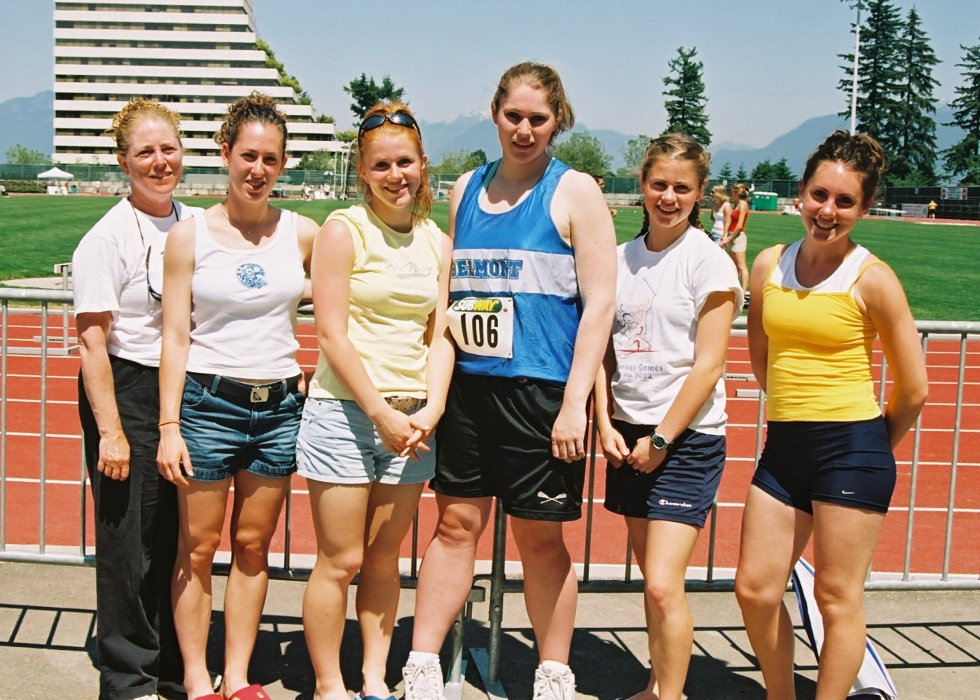
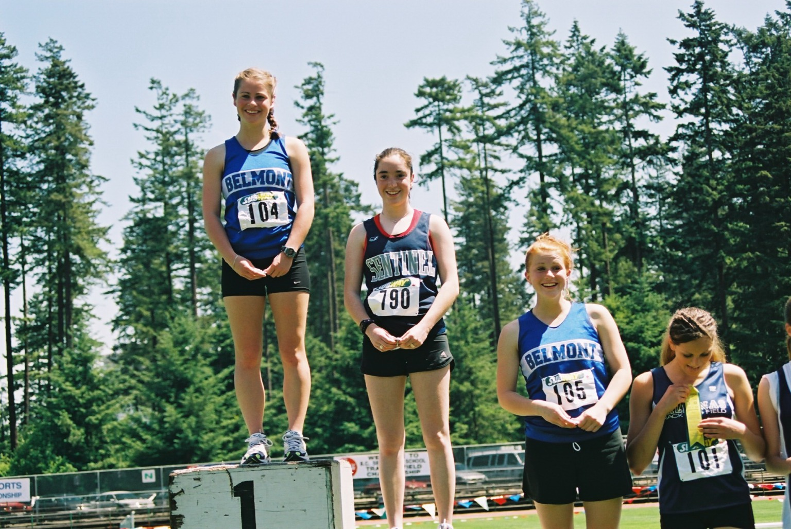
Her advice to current Belmont athletes is to “Follow your passions…even if the people around you disagree, or think your goals are stupid or unreachable. If you don’t give it your best shot when you have the chance, you will regret it!”

