Luca Segato: 1985-1988
Luca Segato was one of Canada’s top cyclists who competed in the 1988 Olympics the same year he graduated from high school! He was an excellent athlete whose first competitive sport was soccer, but by the age of 13, he dedicated himself full-time to cycling. Luca trained extensively outside of school hours, hitting the road both before and after classes. At that time, there was not a strong school program, but Belmont art teacher Earl Mansfield, who shared Luca’s passion for cycling, organized a cycling club and took the students to the only race of the season around Shawnigan Lake. Luca is appreciative of Mr. Mansfield’s support and recalls that whenever he sketched anything cycling-related, he always received top marks.
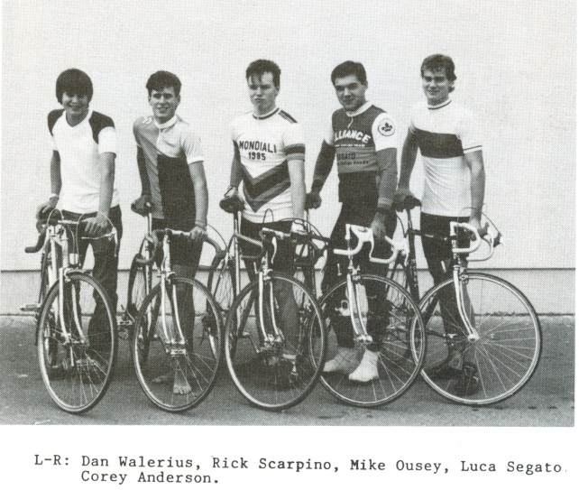
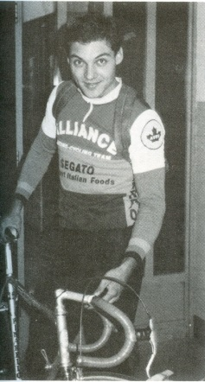
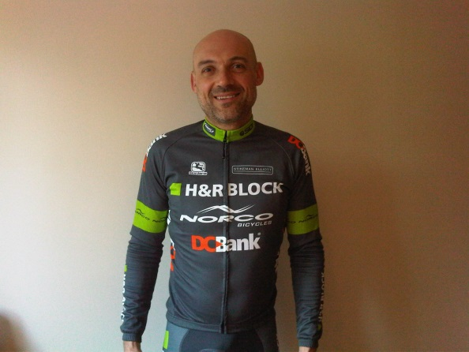
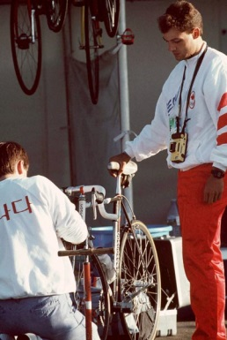
As a teenager, Luca ascended up the national rankings and was selected to compete for Team Canada at the 1987 Junior World Cycling Championships. Belmont school administrators granted him two academic credits for his cycling accomplishments, which allowed him to graduate a semester early in January and fly to Italy to compete. He returned to Canada in June and won the Olympic Trials as an 18 year old. He interrupted his intense training schedule to come back to Belmont to attend his high school graduation ceremony before heading off to Seoul, South Korea to compete in the Olympic Games. After the Olympics, Luca turned professional and competed in Europe for many years.
Cycling has played a major role in Luca’s life. Besides providing an opportunity to compete for his country and to earn a living from the sport, he also got to travel the world and experience various cultures. He strongly feels that the "direct learning" from life experiences is a great tool. At present time he directs Team H&R Block professional cycling team and has an import/export business. Luca values the lessons that cycling has provided and says “I would consider my ability to endure and sacrifice an asset in life. The discipline, which sports reinforce, is a mandatory tool in the step towards a successful career in any profession.”
Luca was inspired by his grandfather, who won gold and silver medals in cycling at the 1932 Los Angeles Olympics and by his cousin who competed in the 1972 Olympics, both for Italy. He also was positively influenced by his first coach, Elmar Bertelsen, whom he met at the age of 13 at his first race. The two men are still in contact today, and Luca describes him a second father and considers him to be Canada’s greatest cycling coach!
When asked what advice he would give to current Belmont athletes, Luca replied: “Let your passion be your influence. I was wearing lycra and flourecent clothing in the 80's, I was bullied and called "gay" many times. My passion was stronger and I wasn't bothered, I don't have a confidence problem and I'm very focused when I have a goal in mind. So, follow your passion, it will take you where you're supposed to be, always.”
Luca age 17
Luca as a director of H&R Block Cycling

