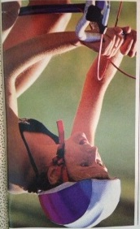
Karen Rainey: 1978-1981

Karen Rainey was a terrific all round athlete who was involved in seven different sports during her time at Belmont: basketball, volleyball, cross country, field hockey, track and field, gymnastics and swimming! She even found time to play in the band for two years. She got her start in competitive sports at the age of 9 when she joined the Juan de Fuca Coho swim program and would remain with the club for the next seven years.

Karen achieved both individual and team success during her high school sporting experiences, and was one of the top runners and swimmers on the Island. She was a leader on the 1979-80 girls’ cross country team that captured both city and Island championships and finished fifth in the province. Karen won the individual bronze medal at the BC’s that year. She was also a key member of the Belmont swim team that consistently challenged for Island supremacy, and won an individual race at the BC Track and Field Championship. Her accomplishments didn’t go unnoticed, as Karen was selected as Belmont’s outstanding senior girls’ athlete in 1980, despite the fact she was only in grade 11. Although the individual accolades were appreciated, Karen says her best Belmont memories revolve around the comradery and shared team experiences. She especially remembers the cross country team, coached by Tom Holmes, as being a group that had so much fun together.

UVic coach Ron Bowker recognized Karen’s talents and recruited her to race for the Vikes. Karen represented UVic on both the cross country and track and field teams, and was a key contributor to the UVic groups that captured CIAU national cross country titles in 1985 and 1986. Individually, she won the silver medal in the 3000 meter event at the university national championship track and field meet in 1984, and two years later, earned bronze at the same distance. She also achieved a number of other impressive individual honours. She won the gold medal at the Canadian junior national cross country championships in 1981-82, was named to the Canada Games team, placed 7th at the Canadian senior women’s cross country championships, and represented Canada for the Ekiden Japanese 10K road relay. At the age of 20 Karen switched her focus from running to triathlons and became a highly successful professional triathlete for the next ten years, travelling all over the world. She was B.C. Champion, Canadian champion, and went on to win the Vancouver International Triathlon, beating the #1 triathlete in the world!

While there were many people who supported Karen in her athletic success, she is reluctant to list them in case she accidentally leaves someone out. However, there is one individual she singles out as her biggest supporter: “the person who drove me to everything, was my BEST cheerleader and even flew ½ way around the world to keep me company for a race… my Mom, Shirley Rainey.”

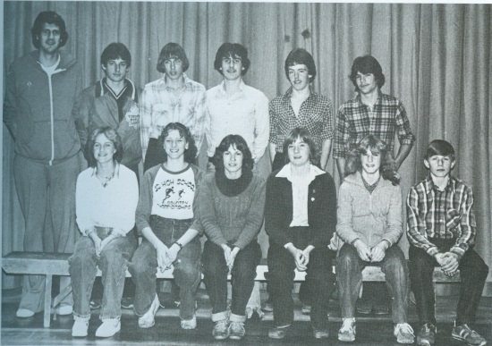
When asked what advice she would give to current Belmont athletes today, Karen responded: “Do whatever makes YOU happy. You need to remain true to who and what you are. If your path is a struggle, chances are you are on the wrong path. There is no such thing as luck. I believe in "Good Fortune where hard work and opportunity come together."- Oprah. Finally..."Great spirits often meet violent opposition from mediocre minds."-Einstein
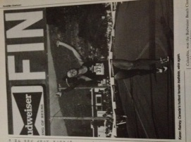
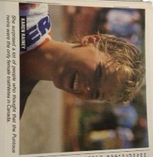

Karen is seated 2nd from the left with Belmont’s 1979-80 cross country team

