Karen Coutts Sjolie: 1976-1981
Karen, affectionately known as “Couttsie” to her team-mates, was a terrific all round athlete who was a key contributor to many of Belmont’s sports teams for her five years at the school. She participated in cross country, swimming, field hockey, badminton and track and field, and helped lead several of those groups to top finishes in city, Island, and provincial competitions. In recognition of her accomplishments, she was selected as the school’s outstanding junior athlete in two consecutive years, in 1977-78 and 1978-79.

Athletics always played a significant role in Karen’s life, and she started swimming at the age of 9 with the Juan de Fuca Coho’s and would rise to a national level in the sport as a teenager. Karen became one of the anchors of Belmont’s terrific swimming program in the mid 1970’s that consistently was ranked amongst the top ten teams in the province. In 1977, she won the gold medal in the breaststroke at the city championship meet and helped lead Belmont to an Island title. She was also a strong cross country runner and along with Karen Rainey, and Karen Talmon, formed the nucleus of a powerhouse squad that rolled through the city and Island competitions, winning gold at both meets, and recorded a fifth place result in the BC Championship race.

The social aspect of sports was always very important to Karen, and she values the special and life-long friends she’s acquired through her participation in athletics. Not surprisingly, her best Belmont memories revolve around the cross country and swimming road trips. There were many coaches who helped Karen achieve her athletic success, but she singles out Belmont teachers Valerie Baker and Tom Hatcher as particularly positive influences.
Karen has remained active in the decades following high school graduation. She continued to swim for many years with the Uvic, Squamish and Whistler Masters teams. She also enjoyed recreational mountain biking and considers one of her highlights to be completing triathlons. Currently she is training for the BMO half marathon in May.

When asked if she had any advice for current Belmont athletes, Karen replied, “Stick with it, do the best of "YOUR" ability and always have fun!!! I have and still have great friends through sports!”
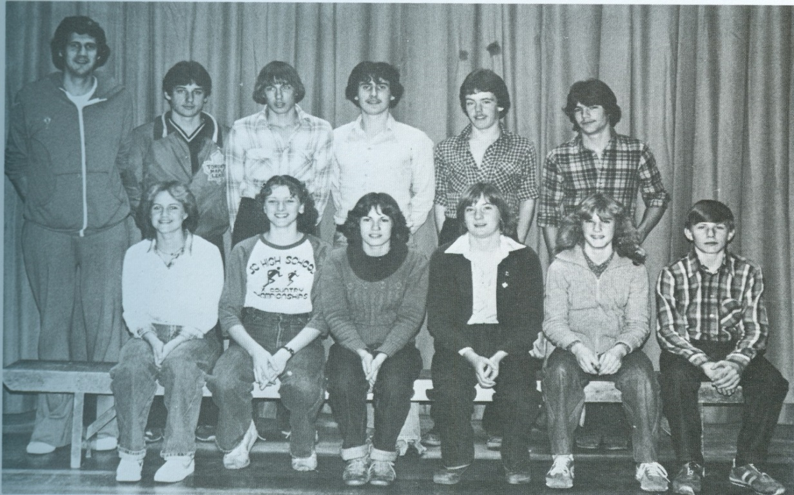

Karen is sitting 3rd from the right with the 1979-80 Belmont cross country team that captured city and Island titles. The other two Karens (Talmon and Rainey) are seated to her immediate left).

