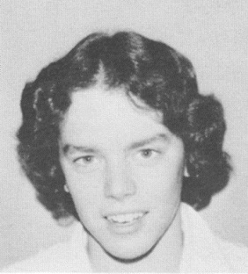
Julie Rainey Jones: 1973-1976

Julie Rainey was a talented athlete who made her mark in swimming, cross country and track and field at Belmont in the mid 1970’s. She started swimming competitively with the Flying Y club in grade 8 which helped her develop into one of the key contributors to Belmont’s strong swim team. In her senior year, Julie earned a silver medal in the 200 meter breaststroke at the Vancouver Island Championship meet, and a few weeks later, captured gold at the BC’s in the 200 meter mixed freestyle relay with team-mates Doug Portelance, Martin Sabel, and Lorraine Morrison.

Distance running was Julie’s other athletic forte, and she was a perennial contender in the district cross country meets. In 1976, she was the top performer on the girls’ cross country team that placed 2nd on Vancouver Island and 5th in the province. This was not her only terrific cross country result. The previous year she had placed 2nd at the Island championship at Thetis Lake and became the only Belmont-Fisher to advance to the BC’s. She ran another strong race at provincials and captured the individual bronze medal. Belmont didn’t have an official track team Julie’s senior year so athletes just trained on their own, but one of Julie’s best high school sporting memories was winning the 1500 meter race at the All Schools Relay and in record time. She also recalls a memorable race at the provincial championship 1500 meter race, when she, Sharon Doherty and future Canadian Olympian Sharon Young were all vying for top position. Sharon Young ended up taking the gold with Julie earning the silver and Sharon Doherty the bronze in an exciting finish.
Athletics continued to play a major role in Julie’s post-secondary life. She swam for the UBC Thunderbirds and was a member of the gold medal 400 meter relay team at Nationals. This was a particularly satisfying result for Julie as she went in with the slowest time of the 4 women on the team, but clocked the fastest result in the final, which alleviated her worries about possibly letting the others down. After university, Julie continued to swim at the Masters levels and still holds some provincial masters’ records.

Her advice to current Belmont students is “to try your best and have fun.”

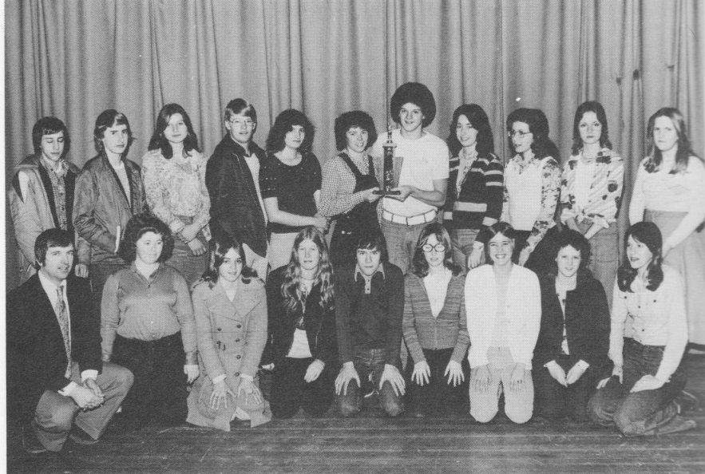
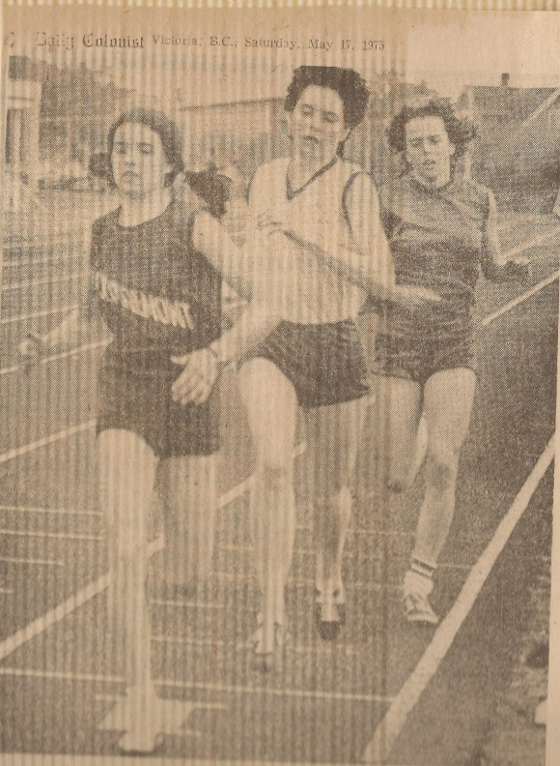
Julie with the 1975-76 silver medal Belmont swim team. She is standing in the back row holding the trophy with Doug Portelance.
Julie (running 3rd in this photo) at the 1975 Lower Island Track and Field Championship meet in the 1500 race. Julie finished 2nd in the event behind Debbie Scott from Claremont.

