Jonathan Smirl: 1995-1997

Jonathan Smirl was one of the most versatile athletes ever to attend Belmont, as he attained a high level of performance in multiple sports, becoming the first student in the school’s history to earn team MVP in four separate sports in a single year! Not surprisingly, he had many athletic highlights at Belmont. In swimming, he won a gold medal at the provincial championship in the 4x100 meter freestyle relay with team-mates Cliff Smirl, Scott Shea, and Carlos Cohelio. Jon says this accomplishment was extra special because he got to share it with his brother on the team. That same year, Jon was chosen as the recipient of the Bob Smirl memorial trophy for the high school regional swimming championship. He was also named to the regional All Star team for rugby in both grades 11 and 12, and won medals in swimming and rugby at the BC Summer Games. In recognition of his outstanding achievements, Jon was named Belmont’s top male athlete in his grade 11 and 12 years, and also earned the senior Sportsmanship Award in grade 12.

After high school graduation, Jon continued to be heavily involved in sports, both as an athlete and a coach. He competed for Uvic’s varsity swimming and rowing teams, and won the BC Judo Championships! He also competed for Canada at both the age-group Olympic distance and long-distance triathlon World Championships, and completed Ironman Canada and the Yukon River Quest (the longest annual canoe race in the world ~750 km from Whitehorse to Dawson City).

However, despite his extremely impressive athletic resume, Jon says that “The biggest highlight for me since completing my athletic days at Belmont hasn't been as an athlete but as a coach. Over my coaching career, I have been fortunate enough to coach people who have won regional, provincial, national and world championship medals in swimming as well as Ironman Champions. When I moved to Kelowna in 2008, I co-founded the Ogopogo youth triathlon club that has grown to become the largest youth triathlon club in the BC interior. But the biggest highlight and satisfaction that I have had isn't from coaching all of the people who have won the medals and accolades. It has come from helping anyone who is willing to try and put forth an effort to improve over what they have done the day before regardless of the where the placed in a race. Knowing you were able to help improve someone's day and give them more confidence in their own abilities has been by far the biggest accomplishment that I have achieved.”

Jon credits many people for helping him achieve his success. “The biggest influences in my athletic career have been my parents for their support and dedication in allowing me to pursue my dreams. Close seconds were: my brother - who ended up being the best swim coach that I ever trained for, my Judo Sensai Mark Grant - who taught me that there is more important things in life than where you place at a tournament and Mr. Russ Morrison - who was the teacher sponsor for several of the sports teams I played for at Belmont and without his support many of those teams would not have occurred.” Sports continue to play a role in Jon’s life today and he is still an active swim coach.
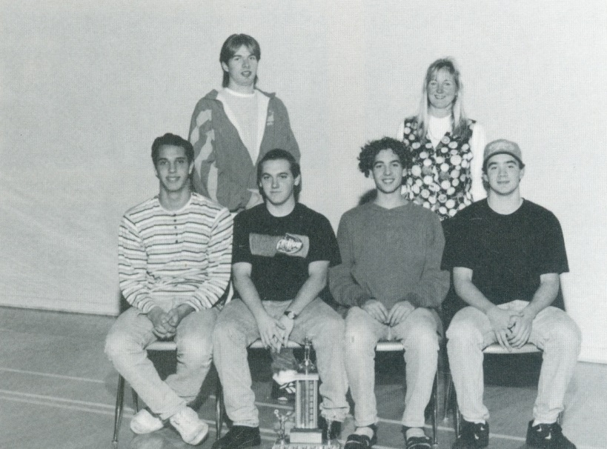
When asked if he had any advice for current Belmont athletes, Jon responded: “The best advice that I can give to any aspiring Belmont athlete is that it is never too late to pursue your dreams and aspirations, whether they are on the playing field or in life. If you are truly passionate about achieving something don't look at the obstacles in the way, instead keep focusing on your end goal and you can always find a way to get there.”
Belmont’s 1996 gold medal winning relay team: Back row: Cliff Smirl and Michelle Choma (coach). Front row: Carlos Cohelio, Scott Shea, Travis Chalmers, Jon Smirl

