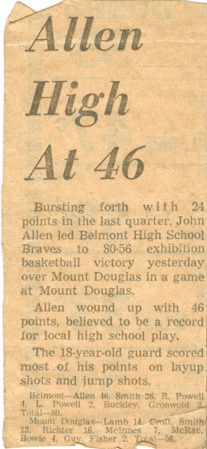
John Allen: 1958-1963
John Allen was a terrific high school athlete who is one of the top basketball point guards ever to play at the school. He was a natural athlete who also was a soccer standout at Belmont, but in the early 1960’s, soccer was more of a recreational game in high school, while boys’ basketball was the feature sport.
John played two seasons for the Braves and soon established himself as the team’s leader and top scorer. During his his grade 11 year, the talented core group, that also included Gary Smith, David Drummond, Paul Drummond and Ricky Powell, had emerged into a legitimate contenders for the city title, but lacked the experience and skill level of teams like Oak Bay. The boys were determined to improve the next season, so that July, they travelled down to Washington State for a week or two to participate in a basketball summer school, which helped them immensely. John also recalls many hours in the summer shooting practicing in the summer on the outdoor court, where the boys played many spirited games to 100 points.
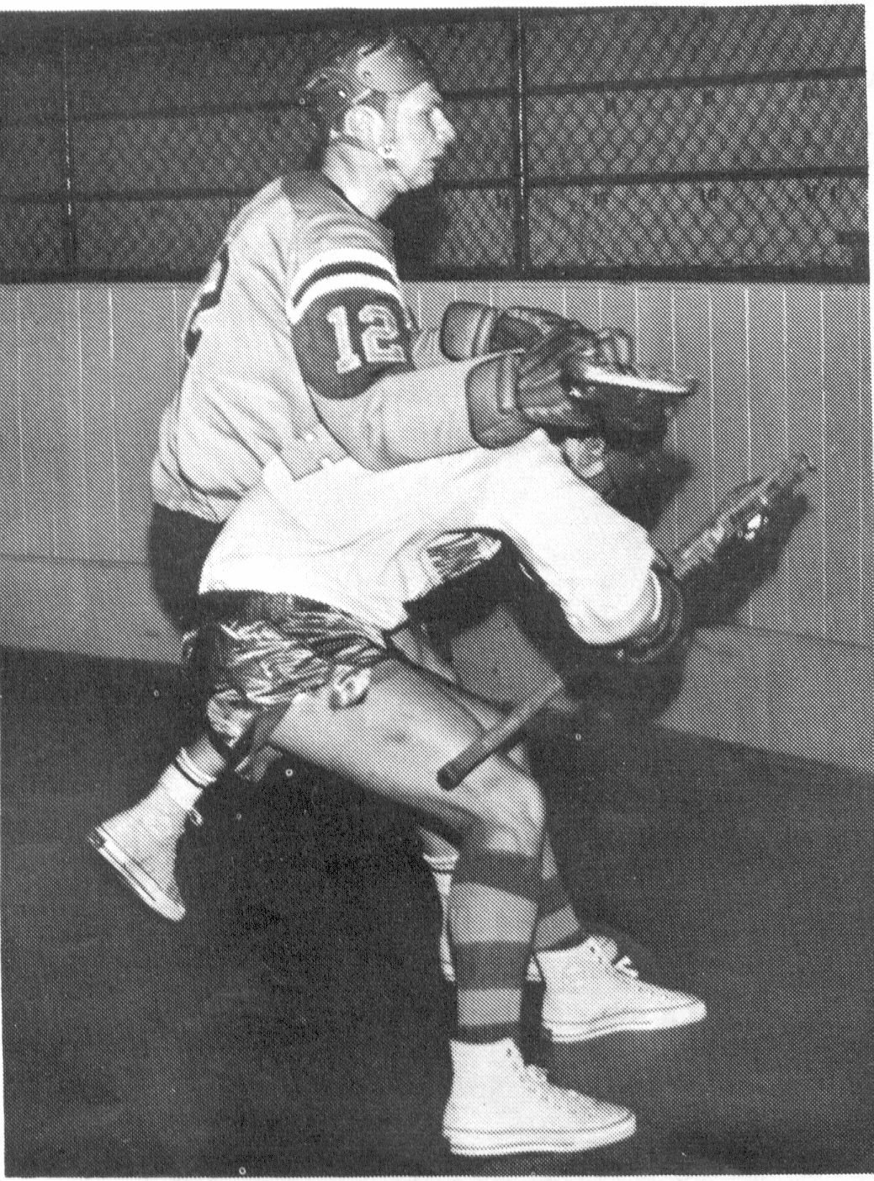
In 1962-63, John ran away with the league scoring title, consistently scoring 20 or more points on a mixture of layups and jump shots. It should be pointed out that there was no three point line in those days, which makes his 46 point performance against Mount Douglas all the more impressive. This was believed to be a city high school record at the time, and would stand as a Belmont record for twenty-seven years until Massimo Segato would record 55 points in the 1989-90 season. Along with John’s scoring exploits, the rest of the Braves’ team also excelled and the boys captured the Lower Island title that year, the first time a Belmont team had every accomplished that feat. John says he thoroughly enjoyed the friendships he developed with a great group of guys and particularly relishes the memory of defeating Oak Bay in their own gym.
Although John was clearly a basketball standout, lacrosse was the sport in which he left his greatest legacy. He played youth lacrosse in Victoria and was a member of the Junior Shamrocks with fellow Belmont grads Rod Kilduff and Mel Spotswood. He remembers the three team-mates bringing their lacrosse sticks to school and practicing in the gym before school or lunch anytime there was open space. After graduating from junior lacrosse, he tried out for the senior Shamrocks but didn’t make their team. He then decided to move to Quebec for a year to play for a lacrosse team owned by John Ferguson, the former Montreal Canadiens’ player whom John had met and befriended in Nanaimo. He had a very successful season, earning All Star recognition, and returned home to Victoria, hoping that the Shamrocks would now be interested in his services. Unfortunately for Victoria lacrosse fans, the Shamrocks again turned him down, so he went back to Quebec for one more season, where he won the scoring title and was again named an All Star. This time when he came back to B.C., he accepted an offer from the Coquitlam Adanacs to play for their WHL team, and he earned Rookie of the Year honours his first season. He went on to become a seven time All Star, recording career 995 points, and later was inducted into the Canadian Lacrosse Hall of Fame. John has remained active in the lacrosse community for the past twenty-five years, coaching a variety of teams.
John says long hours of extra practice and repetition allowed him to go from a good athlete to a great one. His advice to current Belmont athletes is to “Put everything into your sport – that extra time will pay off.”
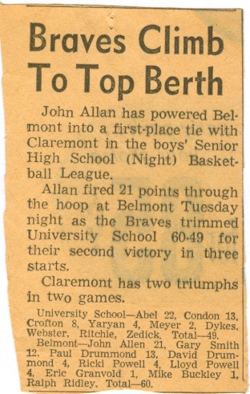
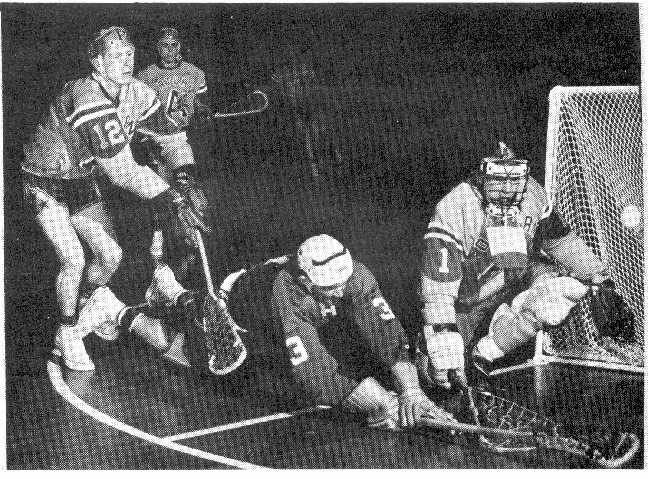
Coquitlam Adanacs photo
John is #12.
(Coquitlam Adanacs website photo)

