Jessica Von Schilling: 2005-2008
Jessica, a talented all round athlete and top scholar, was a valuable contributor to Belmont’s athletic program during her three years at the school. She was a star performer for the Bulldogs’ volleyball, basketball teams in grade 10 and 11, and was selected as Belmont’s top female athlete for both those grades. In her grade 12 year, she decided to concentrate solely on volleyball, as she accepted an offer from UBC to play for them the following season. Cindy Cullen, her junior basketball coach, believes that Jessica would have also received offers from CIS coaches in basketball had she played her senior year, as collegiate coaches had already expressed interest in the 6’1” athlete after her strong grade 11 performance in the Island championship tournament.
Jess first started playing sports at a young age in the community, and her father coached her Juan de Fuca youth soccer team in elementary school, in the days when boys and girls competed together. However, she only started participating in competitive sports in grade 10, both through club and high school teams. Her high school coaches remember her as an incredibly hard worker, a quick study, and a humble and supportive team-mate. She also picked up two of the more unusual sports nicknames: Duchess and Purple! Jess considers her top Belmont sporting accomplishment to be helping her volleyball team qualify for the senior girls’ provincial championship in 2007-08 and earning a second team all-star award at that event. Her best Belmont sports memory was traveling down to San Diego with her grade 10 basketball team at Christmas time. She describes it as “an experience like no other.”
After high school graduation, Jess moved on to UBC and became part of one of the greatest athletic feats in CIS history: winning 5 consecutive national championships with her Thunderbird team-mates! Always quick to give credit to others, Jess recalls a number of people who helped her reach her high level of performance in volleyball: “I was blessed to have a strong support group and indicating one individual is a difficult task. My high school coach Mike Toakley believed in me when I was just a bundle of potential and spent countless hours helping develop my volleyball skills. My parents have always given me love and support for all my life choices and made being an athlete easy. My high school teammates were encouraging and my university teammates were my second family. Every struggle to make it to practice, every hardship they helped me through. And last but not least, my UBC coach Doug Reimer is a coach like no other who listened, who cared about athletes as people and I could never thank enough”
While Jess says her competitive years are done, she hopes to give back to the sport by coaching and to keep playing volleyball in fun leagues. Her advice for current Belmont athletes is to “Look after your body. Your body isn't invincible and if you want to continue playing the sports you love then you need to maintain healthy nutrition, strength training, stretching, etc.”
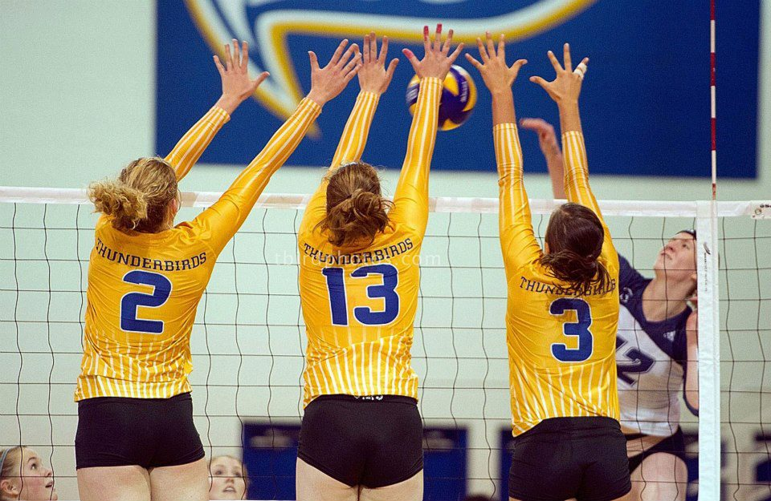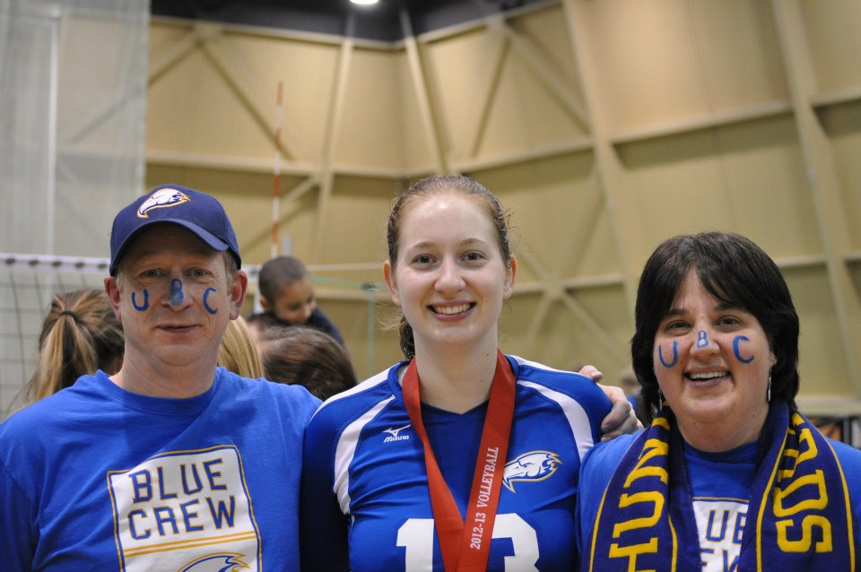
Jess with her parents after winning the CIS Nationals
Jess is #13 going up for a block with her UBC team-mates.

