Harold Parrot: 1947- 1966
Mr. Harold Parrott was one of Belmont’s original teacher and taught at the school for 19 years. Athough born in Victoria, he started his teaching career in Northern BC in a one room schoolhouse in the village of Cadar Vale along the Skeena River, and also taught in Smithers and Port Renfrew before returning to his hometown to accept at position at Belmont for its inaugural 1947-48 year. From the outset, Mr. Parrott took an active role in all aspects of the school community, and was always willing to volunteer his time to work with the students. He was a primary organizer of the early house system of competition, sponsored the yearbook, coordinated special events, and coached numerous sports teams. He was particularly interested in softball and basketball, and coached the senior and junior boys’ teams his entire time at Belmont.
His former players talk about him with great respect, describing him as a true gentleman and someone who genuinely cared about his students. The 1952-53 Blue and White Belmont Yearbook paid tribute to Mr. Parrott: “Many of us will remember Coach Parrott as a man who is an enthusiastic as the players, and takes an interest in each individual team member.” That enthusiasm even extended to dressing up in costume at pep rallies to fire up the students. Besides being well-liked and respected by the students, Mr. Parrott also showed leadership with his colleagues, and was appointed as Belmont’s first vice-principal in 1956. He continued to coach and stay actively involved in all school events until 1966, when he was selected at the first principal for the new Dunsmuir Secondary School.
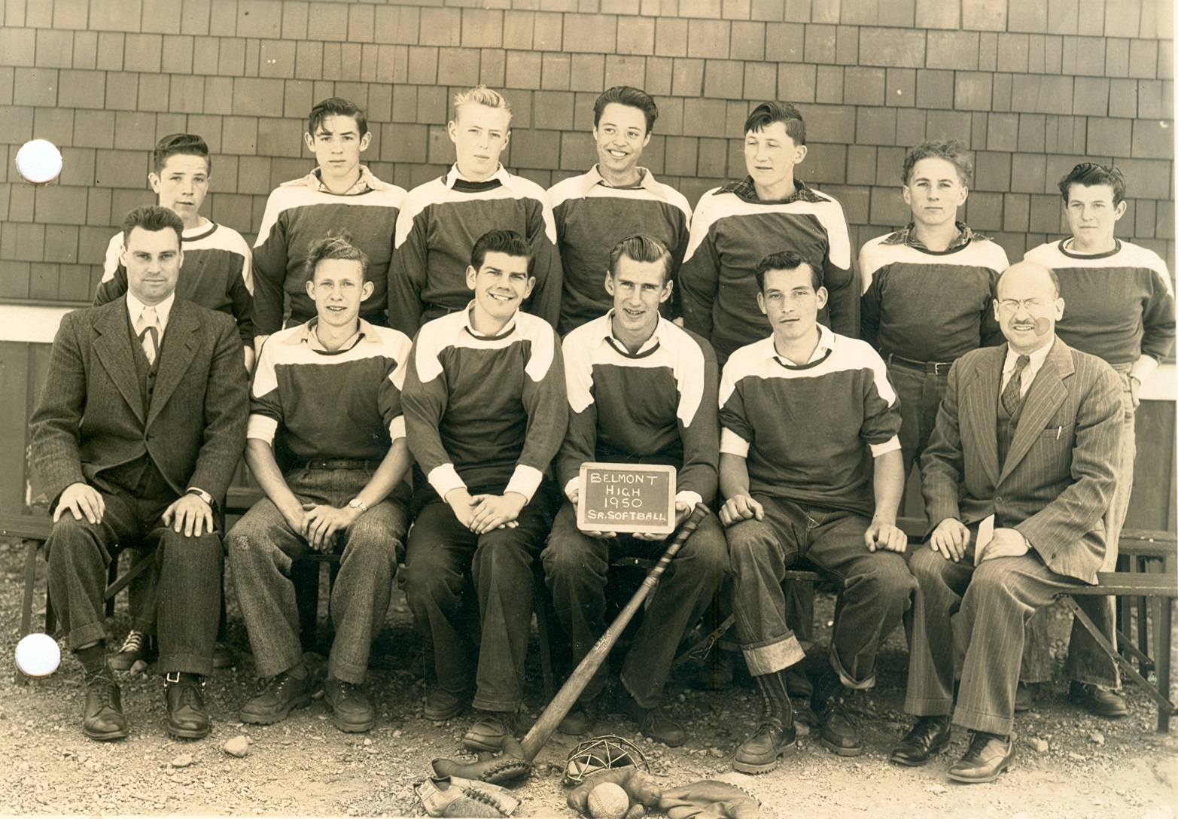
Mr. Parrott is sitting in the front row on the far left with Belmont’s 1950 senior boys’ softball team. Principal Archie Stephenson is seated on the far right.

