
Denise Montgomery Myhre : 1972-1974

Denise Montgomery, co-winner of Belmont’s top female athlete in 1973, is a prime example of an individual who has embraced a sporting lifestyle. She was an active youngster who first became involved in organized sports in elementary school. She and her classmates practiced for months for the intense sports day that occurred at the end of each school year. Team sports started in grade 5, and she took advantage of the fact that the gym was open to students before school, at lunch and after school, even if a supervising teacher wasn’t available.

She became a key contributor to Belmont’s athletic teams, participating in volleyball, basketball, and track and field (sprints, high jump and long jump). Her 1973-74 senior girls’ volleyball team was the first Belmont group to advance to the provincial championship tournament, which was held in the northern BC town of Kitimat. Denise has fond memories of that trip. She recalls that “it was a really big deal” as most of the girls had never flown in an airplane before, and many had never even eaten in a restaurant.

Volleyball continued to play a central role in Denise’s life after high school graduation. After a few years out of school, Kent Andrews, the University of Victoria women’s coach, contacted her to ask her to come out for the Vikettes team. She accepted his offer and never looked back, playing four years of varsity ball and earning her Bachelor of Education degree. She continued with the sport on a club team coached by Kent Andrews. She still plays for FOG Canada and was selected to Canada’s over 50 National team which meets every two years for an international tournament in Utah. Highlights of Denise’s post-secondary volleyball experience include twice winning the gold medal with the over 50’s national team, winning gold at the 2013 World Master’s Games in Italy, and being selected to run in the torch relay for the Vancouver Winter Olympic Games.

Denise gives credit to Kent Andrews as being a very positive influence in her life. She also appreciates the fact that Diane Savoie, a teacher/coach at Dunsmuir School, recognized her potential and gave up her time to coach the girls morning, noon, after school, and on weekends. Denise’s sporting legacy to Belmont continued in the early 2000’s, when her daughter Darla Myhre led the senior girls’ volleyball team to their first ever provincial championship and was named MVP at the BC’s. Her nephew Tyler Hass, a basketball and lacrosse standout, is also in Belmont’s Sports Hall of Fame.

Denise’s advice to aspiring young Belmont athletes is to “Be the best you can be at every practice and competition. Your sport will take you places and open doors for you that you could never imagine. Take advantage of every opportunity that comes your way.
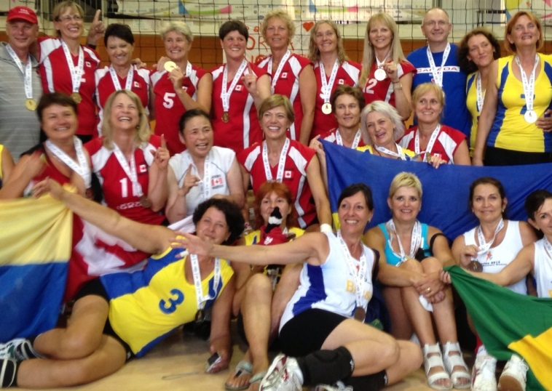
Denise at the World Masters Games in Italy. She is #12 for Canada, standing in the back row next to the coach in the blue shirt.

