David Bennett
Dave Bennett attended Belmont as a student, graduating in 1978. He went out for the rugby team at that time, but a knee injury put an end to that sport, and he didn’t play on any other school teams. He did, however, really enjoy his P.E. classes taught by Muzz Bryant and Bill Spotswood. Belmont didn’t have a football team at that time, but Dave was an enthusiastic B.C. Lions fan and regularly travelled to Vancouver to watch CFL games, an extra special experience since his older cousin Paul Giroday was a linebacker on the team from 1975-1979.
Dave first became involved with the Warriors Western Communities football program when his son got into the sport. He was asked to take on the role of assistant coach for one season, and then took over head coaching duties the following year and worked his way up through the pre-Atom, Atom, Peewee and Bantam ranks. He stayed with the Warriors for thirteen years altogether, long after his son had graduated.
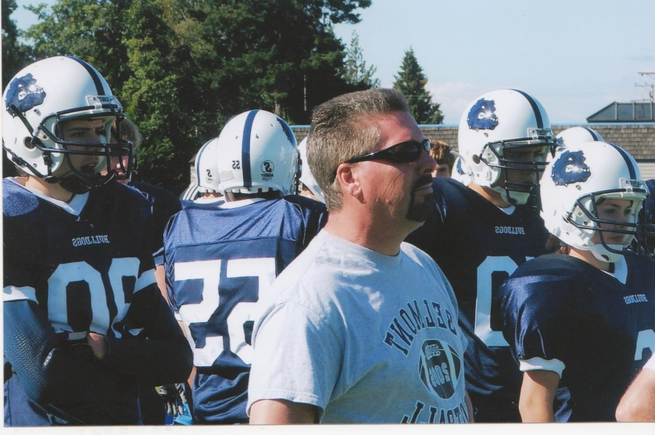
Starting a high school football program had long been a dream of Dave’s and he hoped to get a team established at Belmont that could eventually rival those from Mount Doug and John Barsby, two powerhouse schools on Vancouver Island at that time. Dave approached Belmont athletic director Muzz Bryant, who said that it would take a lot of organization and money, not to mention a teacher sponsor, for a team to get off the ground. Dave wasn’t discouraged by the lack of an immediate “yes” answer, and spent the next four years laying the groundwork. He met with Belmont PE teacher and girls’ basketball coach Kevin Harrington, himself a former junior football star, to discuss the possibility of Kevin getting involved. He also devoted countless hours to fund-raising and struck a partnership with the Victoria City Police whereby Dave would take unclaimed stolen bikes and sell them at auction. In 2006, by the end of four years, he had raised an astounding $40,000, enough money to buy uniforms and equipment for a new team. Kevin Harrington decided the time was right to step away from basketball and come on board as the Bulldogs head football coach.
Those first few years involved some growing pains, as many of the boys had never played the sport before and had to develop the skills and fitness that more established programs took for granted. But through long daily practices and lots of encouragement, the team improved steadily and became competitive with many of the Tier 2 teams on the Island, losing in the BC finals to Frank Hurt in a well fought game.

Although it has been very satisfying to see the improved results on the field, Dave says his biggest reward has been the personal connections he formed with the athletes. He relishes the fact that football created a positive family atmosphere and recalls that some the boys on those early teams said the only reason they stayed in school was because of the football program. He loves running into his former players in the community years later and getting caught up with their lives. He is also proud of the fact that some of the Belmont players earned university scholarships and were able to continue the sport while getting their education.
When asked about the impact Dave has had on Belmont’s athletic program, Kevin Harrington replied: “Dave was an integral part to the start and continuation of the Belmont football program. Without his dedication, forethought and financial support the Belmont football team would have never gotten off the ground and the success you are seeing now would have never been a possibility.”

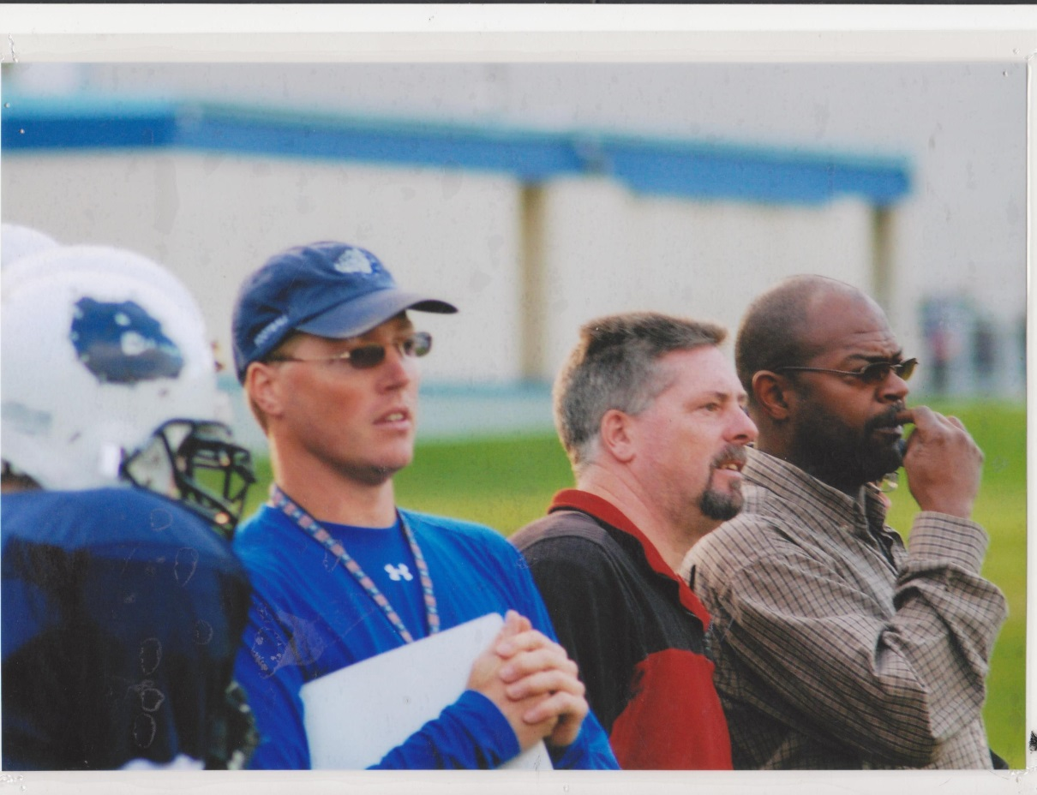
Coach Dave (in the red shirt) watches the football game from the sideline.

