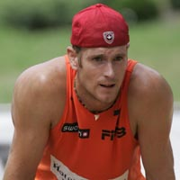
Darren Goss
When Darren first arrived at Spencer Junior High School, he was a promising basketball player who seemed likely to seriously pursue that sport throughout his high school years. However, Spencer coach Mike Toakley introduced him to volleyball, and Darren took to the game with passion, and soon became one of the top players in the province for his age. He and a group of close friends and team-mates that included Belmont Sports Hall of Famers Ben Gollmer and Mike Strandlund led the Spencer Knights to the provincial title in their grade 10 year.
That was a prelude to their experience at Belmont, as in 1997-98, as that same core group achieved the pinnacle of B.C. high school volleyball once again, defeating arch rival Claremont in a thrilling five set victory in the final match of the BC Championship tournament. This was the first provincial title for Belmont in 50 years! Darren was named MVP of the tournament and was recruited by a number of top Canadian universities.
He played his collegiate volleyball for York University, and was a four time Ontario University League All Star, and was selected as a 2nd team All Canadian his final season. He also was part of the Canada Games gold medal winning team in 2001.
As strong as court volleyball player was, Darren was perhaps even more dominant in the beach game. He and partner Mingo Miguel, also a Victoria native, were two-time junior national beach volleyball champions, and were also selected to compete for Team Canada at the World University Games in 2002 and 2004.
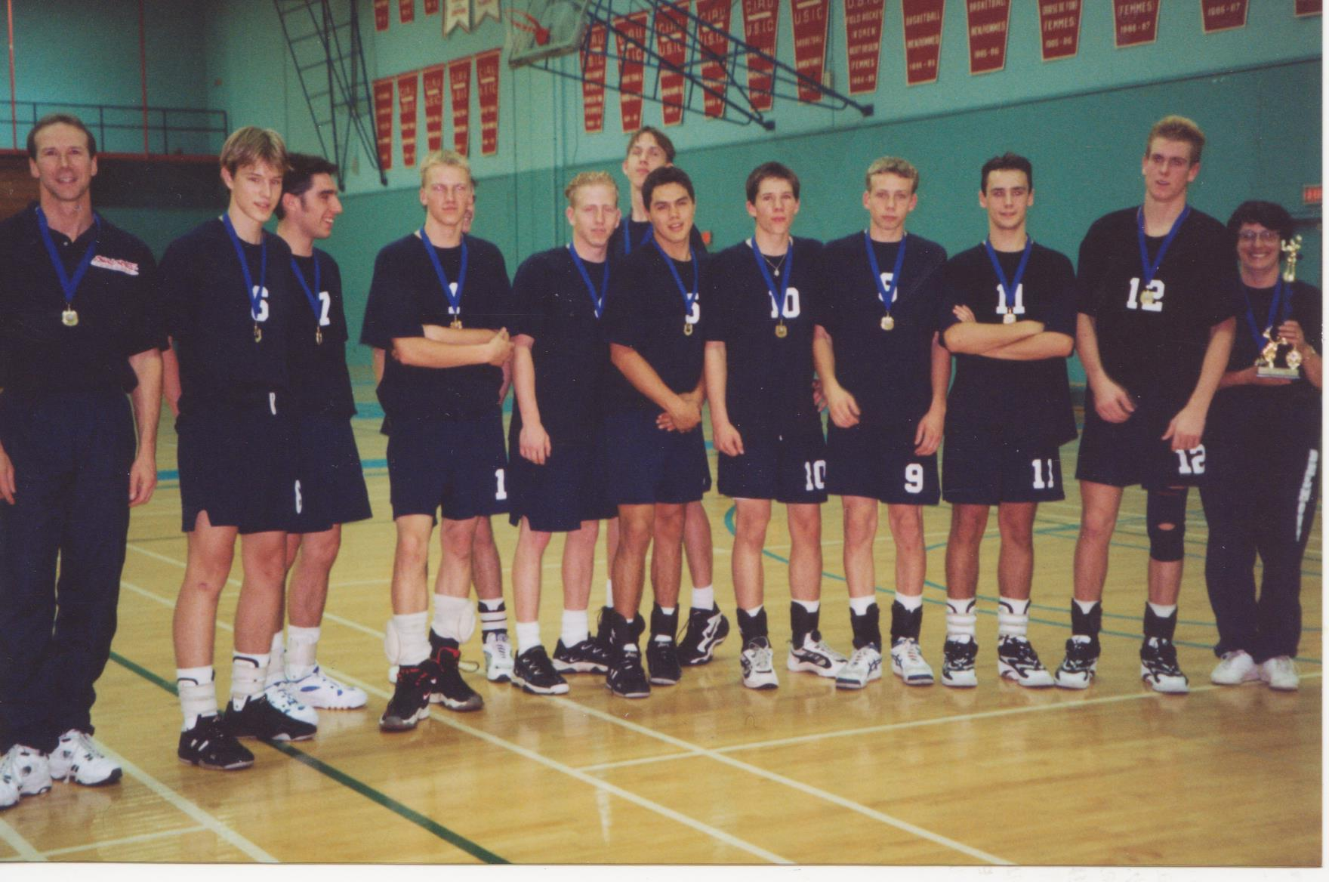
Darren is # 12.

