Darla Myhre (Van Winkle): 2000-2002
Darla was at Belmont from 2000-2002 and was instrumental in leading the Belmont Girls Volleyball Team to their first ever Provincial title in 2001. Growing up, Darla played numerous sports (hockey, softball, field hockey, basketball etc.) However, she didn’t start playing volleyball until middle school at George Bonner in Mill Bay. In grade 9 she joined the Victoria Volleyball Association’s Friday night league.
Starting in grade 10, Darla began playing seriously on a club team affiliated with the Victoria Volleyball Association (the “Koa” – Hawaiian for “warrior”). Her skills improved dramatically, and while with the Koa she would earn a silver medal at the U-17 National Championships and be named to the first all-star team. In 2000 Darla moved from Mill Bay to Belmont, where she made an immediate impact upon the volleyball program. In 2000-01, she was a big part of the team going all the way to a 2nd place finish in the AAAA Provincial Championships in Courtenay and was named a First Team all star. Her grade 12 year was even better, as the girls captured the BC title (in North Vancouver) and Darla was named the tournament M.V.P. Her Belmont and Koa coach, Mike Toakley, fondly recalls that “Darla was a fierce competitor. She hated losing and was constantly pushing herself to get better. She had amazing foot speed for someone as tall as she was and is the most intimidating blocker I have ever coached.”
Darla is #11.
A highly sought after player in both Canada and the U.S., after graduation Darla received a full ride volleyball scholarship to the University of Washington. While at U.W., her team won two Pac-10 Championships (2004 & 2005), and the NCAA Division 1 National Title (2005) in her senior season! During this time, Darla also spent time as a member of Canada’s Junior National Team. After finishing her university career, Darla also played professionally in Spain for a year. She now lives in Washington State, where she is happily married and has two wonderful children.
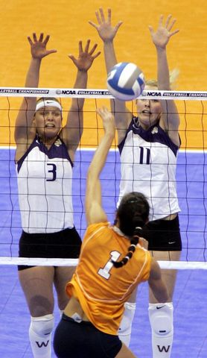
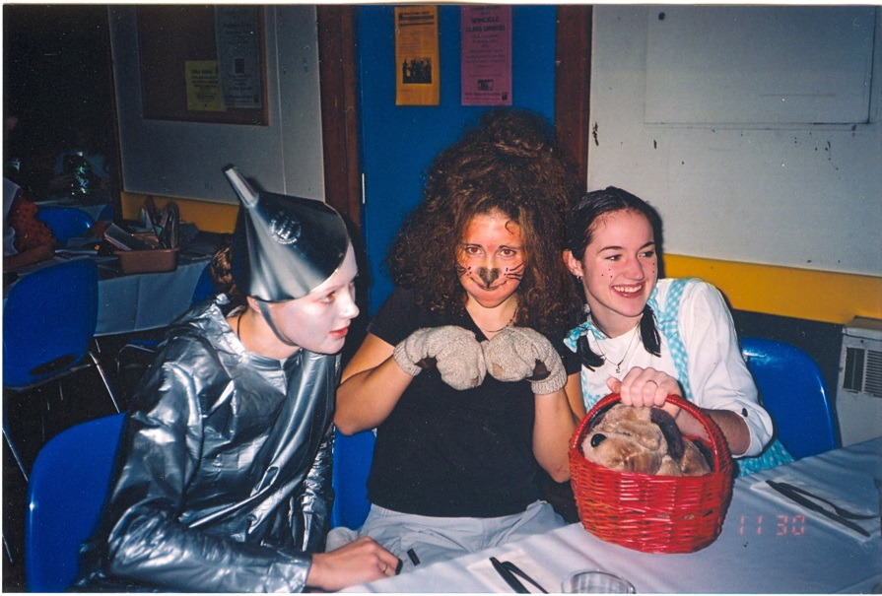
Darla dressed as the Tin Man for the team social night at the BC High School Championship Tournament. The entire team dressed up as Wizard of Oz characters.
Darla is #11 blocking at the net.

