Danielle Meyer Bell: 1998-2001
Danielle was an exceptional high school swimmer who rose to the national ranks while still in high school. She started competitive swimming at the age of 7 and soon started winning races in her age group. As a grade 10 Belmont student, she was a surprise selection to Canada’s national swim team and competed in the 1999 Pan American Games in Winnipeg. Danielle competed for the national team for four years and captured four Canadian titles during that time period. She competed in many international competitions, including the Commonwealth Games and World Championships!
Besides being an outstanding athlete, Danielle was also a top student, and she appreciates the fact that Belmont allowed her the opportunity to travel to train and compete when needed. She says that the flexibility and support of her teachers was what allowed her to pursue swimming at the high performance level.
After high school graduation, Danielle went on to swim for the University of Victoria while completing a Bachelor of Science degree in Psychology. She continued to excel in the pool as well as the classroom, and won Uvic’s “Rookie of the Year” award in 2002. She then decided to work in the sport sector on the Canadian Sport for Life Project, a project that links sport, education, recreation and health. She has really enjoyed using what she learned as an athlete to engage in sport from a different perspective. For the past ten years she has been working on the Canadian Sport for Life Project with the goal of improving the quality of sport and physical activity in Canada. Danielle explains: “ It’s important to me that children have the opportunity to play, and that they learn how to move their body (i.e. they can run, jump and throw), to at least participate in physical activity, regardless of whether they want to pursue sport or not. This will ensure Canada, as a population, is healthier.”
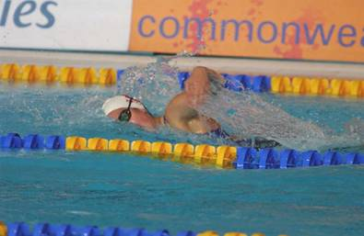
Danielle is grateful to her family and feels that they played a major role in her athletic success: “My mom, dad and brother were incredibly supportive and accommodating. My dad taught me the importance of “play” and movement, whether it was basketball, baseball or swimming. He always had time to play outside with my brother and I. My mom taught me the value of commitment and spent hours each day driving me to the pool.” She also credits coaches Mark Lancaster, Rod Barratt, Ron Jacks & Dr. Peter Vizsolyi for shaping her into who she’s become.
When asked what advice she would give to current Belmont athletes, Danielle replied:” If college or university is important to you, ensure your coach values academia AND sport, not just sport; your career in sport will end, but you’ll need your education forever.” She added, “Don’t be afraid to make change if something isn’t working,” and “Make sure you love what you do, don’t do it just because you’ve always done it.”

