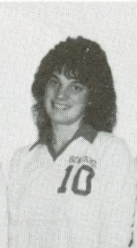
Dana Kinghorn 1988
Dana, recipient of Belmont’s top senior girls’ sportsmanship award in 1987 and top female athlete award in 1988, was a terrific natural athlete who excelled in three sports.
Dana was a high school basketball and soccer standout, who used her height, speed, strength and intelligence to dominate the opposition. In soccer, she mainly played as a defender, and made it tough for opposing forwards to create scoring chances. In 1987-88, she led Belmont to a fourth place finish in the province and was selected MVP of the championship tournament, an honour usually given only to a player from one of the top three teams. In basketball, she consistently was one of the Tomahawk’s leading scorers and rebounders, and earned All Star recognition at a number of tournaments.
Despite her impressive accomplishments in soccer and basketball, softball was perhaps her best sport. She was an outstanding catcher and earned a tryout with Team Canada for the 1996 Olympic team.
Dana’s coaches remember her as a classy individual and said she combined a fierce competitive spirit with a positive, fun-loving personality and a strong commitment to fair play. She was a strong leader who was popular with her team-mates and well-respected by everyone in the sporting community.

