Dailene Sivertson: 2006-2008
Dailene was a talented natural athlete who participated in a number of physical activities as a child, including T ball, swimming, basketball and dance. But after watching Sandra Schmirler’s Saskatchewan’s rink win a gold medal for Canada at the 1988 Winter Olympics in curling, Dailene became intrigued with that sport and developed into one of Canada’s finest young curlers.
As curling was not offered at elementary or middle school, Dailene played in community leagues and quickly rose up the ranks. By the time she entered Belmont, she was one of the top junior females in B.C., which meant she didn’t have time to play on other school teams such as basketball, even though she would have been a welcome addition to the team. As a Belmont grade 11 student, she skipped her rink to a provincial junior title, and the foursome went on to win the bronze medals at the Canadian Championship event.
After high school graduation, curling continued to play a major role in Dailene’s life. She captured two more B.C. Junior titles, and in 2011 was part of the Team Canada rink that won the silver medals at the World Junior Championship. She also earned a silver medal at the Canadian Senior Women’s Championship (Scotties Tournament of Hearts) and participated in the 2013 Olympic Curling Pre-Trials. Despite her busy athletic schedule, she was able to complete her Bachelor’s Degree in Business Administration from the University of Regina. She still competes in the sport and hopes to continue to play on the world curling tour. Her ultimate goal is to represent Canada at the Olympics one day.
Dailene considers herself very fortunate to have had so many people in her life who helped her to achieve success in the sport of curling. She says, “In particular, I could not have done any of the competing without the support of my parents and grandparents. I also had a long time junior coach – Cindy Tucker – who helped me keep on track and prepare for all of the events I was in.”
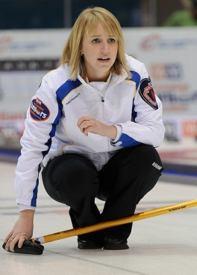
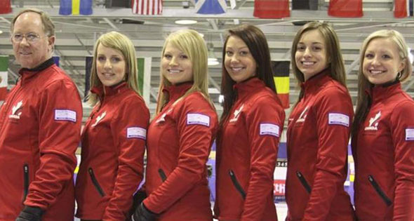
Looking back at her own high school years, Dailene is happy that she put so much work into her chosen sport as it certainly paid off for her in the long run. Her advice to current Belmont athletes is to continue to put in the long hours of practice that is needed in order to excel in competition, while at the same time finding balance in your life.
Dailene is standing second from the left as a member of Team Canada’s 2011 junior women’s curling team.

