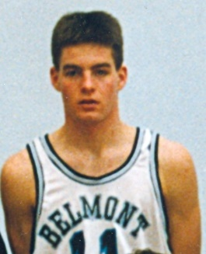
Curt Spaven: 1991
Curt, Belmont’s top male athlete in 1991, was a key contributor to Belmont’s 1991-92 Braves’ basketball team that won the Vancouver Island title and finished third in the B.C. championship tournament. He was named a first team provincial all star and was selected to play in the 1992 BC high school all star game in Vancouver.
Since high school graduation, Curt has remained closely linked to the western community basketball community and has devoted thousands of hours to helping youngsters in the sport. He is an executive member of the Westshore Basketball Association, and coordinates the boys’ night league program. He has also coached numerous teams the past decade, for Wescom, Spencer, and Belmont. In 2015-16, he guided the Belmont Bulldogs junior boys’ team to a Lower Island championship. As an added note, several of his sons have followed in their father’s footsteps and suited up for Belmont. Eric, his oldest son, was a Lower Island scoring champion and Vancouver Island All Star.
Curt enjoys having the chance to give back to the sport he loves, and the Belmont basketball program is grateful for his years of service to the school.
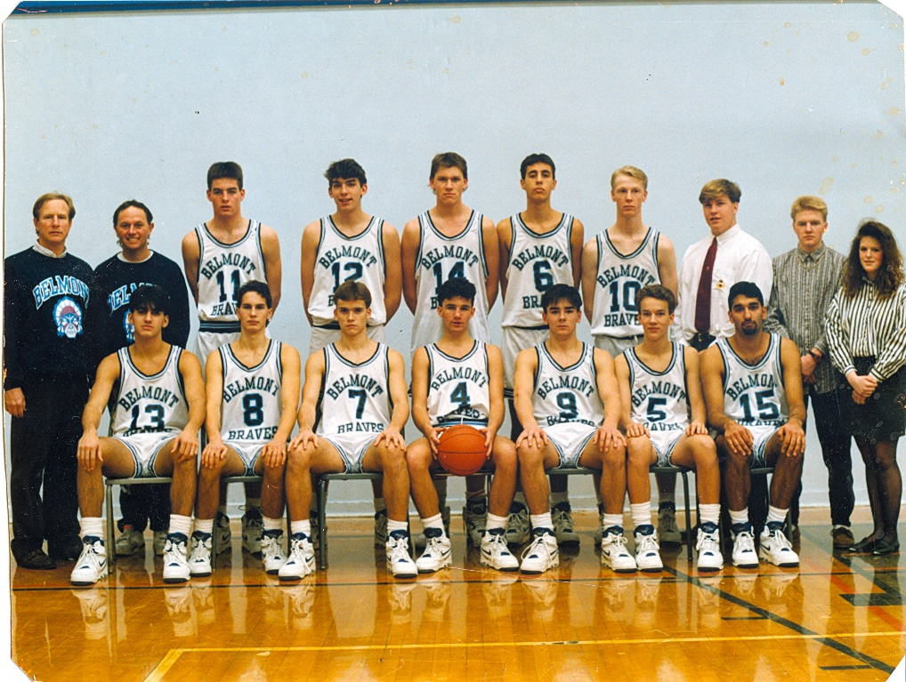
Curt is #11 standing in the back row beside coach Muzz Bryant.

