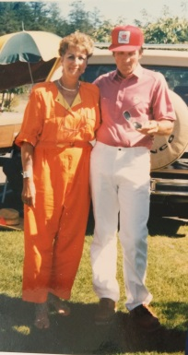
Alan Robertson 1947-1952
Alan Robertson attended Belmont from the year 1947-1952, playing sports and quickly becoming one of the schools’ star athletes. He has always loved sports as playing them came fairly easily to him. He first became acquainted with sports at Langford Elementary School, which is now known as Ruth King. After discovering athletics here, Alan became interested in joining teams outside of school, playing basketball and juvenile softball for Langford. He surrounded himself with sports, if not at school, on a Langford team, or when he got a job as a caddy at Royal-Colwood Golf Course in the 1940’s, being paid $1.00 per round.
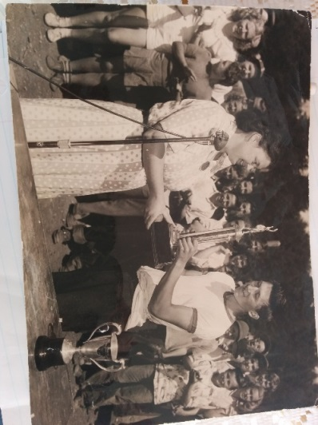
As he got older his interest further developed, leading him to high school sports at Belmont Secondary. Here Alan excelled mainly in softball, where he was famous for his hard hits, and soccer, where he often was the top scorer. Softball was Alan’s main sport and he even acquired the nickname “Herk” short for Hercules, because when he went to bat, he would often hit the baseball right out of the park. He captained the Belmont softball team to many victories, including his best high school sporting memory: winning the Maughan Cup against Milne's Landing (pictured right). Alan also participated in track & field, competing in the 100 yard dash and broad jump, and enjoyed the sport of hockey outside of school. He played on the Bears, which was a juvenile team, from 1949-1950 at Memorial Arena as soon as it was opened. He would go in with his team at 4:00 in the morning, as that was the only available time slot. In the summer of 1951, the year before Alan graduated from Belmont, he joined the cadets and went to Vancouver where he played for the station ball team and was the the only cadet allowed into the bar, as he would enter with his older team-mates.
After high school, Alan worked 2 different jobs; he started on the first stretch of highway from Uptown to Thetis Lake. He then worked at the Victoria Water District, which is now known as the CRD, for 38 years and retired as a road superintendent. Although his life became sidetracked with work and sports weren’t as much of a priority as they were before, he always stayed active. In 1961, Alan won the batting championship in Victoria, and later developed an interest in golf. As usual, getting a handle on a sport wasn't hard for Alan and he quickly improved at golfing. He won the Seniors event twice at Royal-Colwood, back in the 80's and has been a member of that course for 33 years.
Alan Robertson could be called “an original” athlete at Belmont Secondary and he remembers his years at Belmont as some of the greatest times of his life. He was born in Victoria, went to school, graduated, worked, and retired in this city. Retired 20 years ago and revealing his current age to be 81, he still possesses a unique energy inside him, and remains active in his everyday life. When asked what advice he’d give to athletes today his response was this, “Proper training is important as well as the mental approach. Your focus and concentration is just as important as is any part of any sport.”
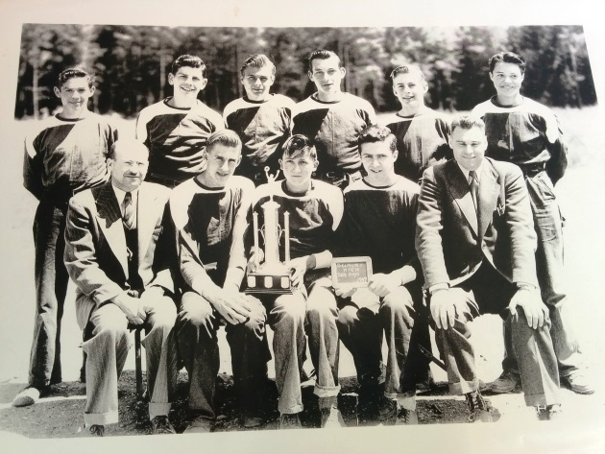
Alan is seated in the middle holding the Maughan Cup with his 1949 Belmont softball team-mates.

