2010-2011 Golf Team
The 2011-12 Belmont golf team consisting of Darren Day, Dylan Bell, Brock Holland, Vince Michaud and Sean Orr had an extremely successful season and ended up as the #2 ranked high school team in the province. The boys trained regularly at Olympic View and Royal Colwood under the watchful eye of Coach Lowe, and were competitive in every tournament they entered. Led by Darren Day and Brock Holland, the boys placed first on the Lower Island and first in the Islands. At the provincial championship tournament in Kamloops, they finished with an aggregate score of 301, six strokes back of the first place team Gleneagle from Coquitlam, good enough to capture the silver medals. Darren Day recorded the top individual score for the Bulldogs. When asked to give reasons for this group’s terrific season, Ken Lowe explained they were a committed group of talented golfers who drove each other to be better each and every round.

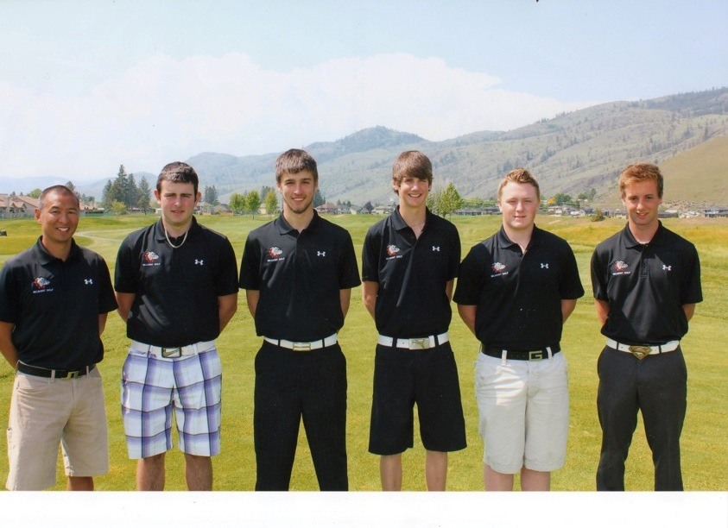
From Left to Right: Coach Ken Lowe, Dylan Bell, Brock Holland,Darren Day, Vince Michaud and Sean Orr

