2001-2002 Golf Team
The 2002 golf team enjoyed tremendous success and became the first Belmont golf team ever to capture a provincial championship. Under the capable coaching of Ken Lowe and Marilyn Kraeker, along with skilled players such as Dustin Pewarchuk, Julianne Kim, Adam Cracknell, Cody Pewarchuk and Dan Roberts on the team, it is no surprise that the group had so many impressive achievements. After qualifying for provincials by placing first in the Island tournament, the team won the BC’s at the Cordova Bay Golf Course with a record combined score of 588. Dustin Pewarchuk won the individual title for the tournament, breaking the previous low score set in 1983, while team-mate Dan Roberts was close behind in second place. This year’s team members all continued to excel athletically after high school graduation. Julianne Kim enrolled at the University of Texas El Paso, Dustin Pewarchuk attended the University of Oregon, and Cody Pewarchuk went to University of Hawaii –all on NCAA golf scholarships. All three of these individuals have returned to Victoria and still play at Royal Colwood Golf Course. Dan Roberts made a career in the golfing business, and Adam Cracknell currently plays hockey in the NHL for the Columbus Blue Jackets.

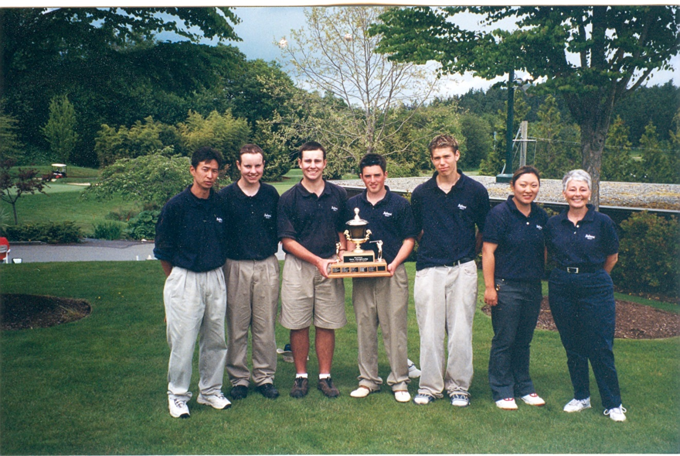
Left to Right: Ken Lowe, Cody Pewarchuk, Dustin Pewarchuk, Dan Roberts, Adam Cracknell, Julianne Kim and Marilyn Kraeker

