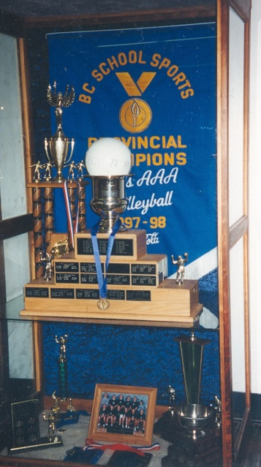
1997-1998 Boys Volleyball
Standing: Barb Gilbert (manager), Mike Toakley (coach), Theo Riecken, Derek Lucik, Bryce Goddard,Gary Venn
Sitting: Adam Stevens, Ben Gollmer, Dustin Price, Darren Goss, Mike Strandlund, Jeremy Douglas
The 1998 boys’ volleyball team, coached by Mike Toakley, was the first Belmont team in any sport to win a provincial title! After the team’s very successful regular season, they went on to win both the Lower Island and Island titles to qualify for the Provincial tournament. Belmont advanced to the BC Championship final, where they took on their arch rival Claremont. It was a close, exciting match that went to a fifth game. Both teams were exhausted yet motivated by the Provincial title so close within their reach, and the Belmont boys pulled through with the win. This marked a tremendous victory for the boys and for Belmont as a school. Notable players for the 1998 team were Darren Goss who won MVP of the Provincial tournament, and Ben Gollmer, Mike Strandlund and Dustin Price who all earned All Star recognition
