1991-1992 Girls’ Basketball
The 1991-1992 Tomahawks, coached by Bill Spotswood and assisted by Cindy Cullen and Teresa Johnson, enjoyed the most successful season in Belmont basketball history, finishing second in the BC Championship Tournament. After their strong fourth place result the year before, expectations were high and the girls lived up to their advance billing by winning the Maple Ridge preseason tournament that featured the top four ranked teams in the province. The team continued its strong play by going undefeated in league play and then winning the Vancouver Island championship for the second straight year. At the provincials, the Tomahawks rolled through their first two games and then defeated the top ranked Salmon Arm squad in the semi-finals. Star guard Lisa Koop poured in 30 points, and added 16 assists and 20 rebounds in a dominating performance, while post player and defensive stalwart Denise Rehman hauled down 24 rebounds. Unfortunately, in the provincial final against a composed New Westminster team, nerves got the better of the girls, as they struggled to find their shooting touch and shot an abysmal 3 /35 in the first half. To their credit, they battled back in the second half and got closer on the scoresheet, but ended up losing 58-46. Lisa and Denise were both selected to the tournament all star team.
The Tomahawks were a well balanced team that received contributions from all players. The front line was led by 6 footers Denise Rehman, Kindree Spotswood, and Amber Thompson, while Jackie DeRaadt, Jenna McMath, Judy Barrett were standouts from the wing position, and Lisa Koop, Tracy Wondga, Marcie Rioux, Torrie Orr, Jenny McIlraith did a great job as guards. The team also had two efficient and energetic managers: Becky Chadwick and Melanie Sawyer.
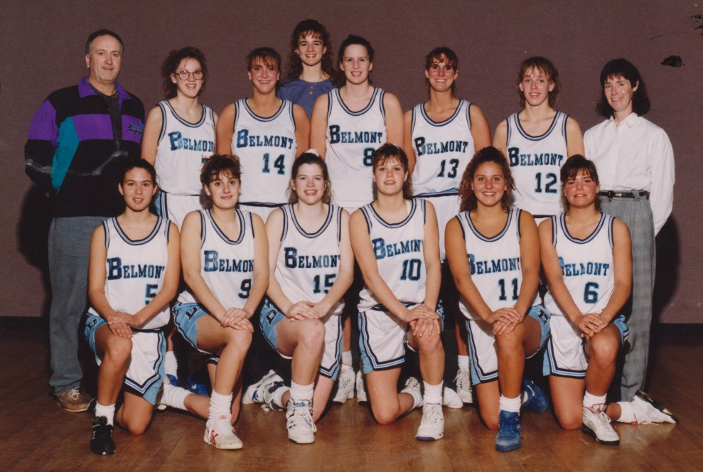
Back Row: Bill Spotswood, Kindree Spotswood, Becky Chadwick, Denise Rehman, Amber Thompson, Jenna McMath, Cindy Cullen
Back Row: Torrie Orr, Marcie Rioux, Judy Barrett, Tacie Wondga, Lisa Koop, Jenny McIllraith

