1990-1991 Boys Basketball
The 1990-1991 Braves coached by Muzz Bryant and Gary Mols, had one of the most successful seasons in Belmont basketball history. Starting the year with a Provincial ranking of 6th place, the Braves competed in many tournaments including one in Waco, Texas! The boys were forced to end the regular season early due to the teacher strike but still qualified for the Vancouver Island Championship tournament as the #2 seed. The team won its first two games but was defeated by SMUS in the final. The second place result qualified Belmont for the BC’s, but they were not awarded one of the top eight rankings for the provincial tourney and would thus face a more difficult draw.
The Braves opened the tournament with a first round victory, which sent them into a matchup against the powerful Pitt Meadow Mauraders, the #2 seed. The Belmont boys pulled off the upset of the tournament, knocking off the Mauraders 70-56. Amrit Lalli paced the Braves with 24 points, and posts Keith Gibson and Chris Olsen dominated inside. This victory sent the Langford boys into a semi-final matchup against #4 ranked Burnaby Central Wildcats. The young Braves’ squad got off to an impressive start against the Wildcats and rolled up a 19 point first half lead, but their opponent’s aggressive full court press proved too much to handle and Belmont ended upon the short end of a 76-62 score. The boys bounced back in the third place match and defeated Vancouver College 84-81 in a thrilling double overtime game. Tom Gilbert hit a clutch shot with 1 second left in the first overtime period to knot the game at 72-72 and force a second overtime. This time point guard Donovan Walters was the hero, as he drained a three pointer with 8 seconds left to earn the Braves the bronze medals .
Grade 12 standout Curt Spaven won many awards, including selection as a Second Team All-Star at Islands and a Times Colonist All-Star. He was also chosen for the North-South All-Star game, and was one of 3 players on the Island selected for the Pepsi All-Star game. Grade 11’s Amrit Lalli and Donovan Walters were also consistent performers throughout the season and received individual recognition in many of the tournaments throughout the year. Other strong contributors included Keith Gibson, Chris Olsen, Tom Gilbert, Cory Boyd and Brad Moran.
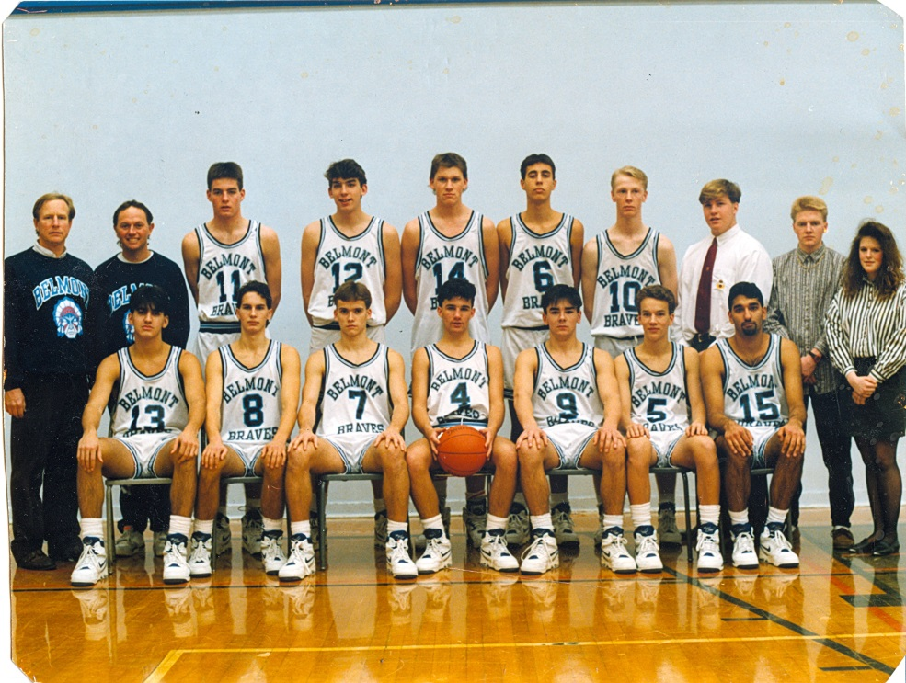
Back Row: Gary Mols, Muzz Bryant, Curt Spaven, Keith Gibson, Chris Olsen, Rob Bergen, Brad Moran, Jeremy Cummings (manager), Chris Kormedy (manager), Michelle Kirk
Front Row: Amrit Lalli, Mike Ericksen, Tom Gilbert, Donovan Walters, Terry Dennett, Cory Boyd, Archie Jaswal

