1971-1972 Boys Basketball
The 1971- 72 boys’ basketball team was the most successful in Belmont history: throughout the season the team ended with a 26-6 win-loss record in both league play and exhibition games. Led by Coach Russell, the Braves had a regular season record of 13-1 which allowed them to capture the league title. They then went on to the Vancouver Island tournament where they defeated Oak Bay in the final game. Lee Edmondson, John Hunter, Jim Kupiak were named to the Island First All Star Team and Lee was also named “Most Valuable Player” of the tournament. The Braves then advanced to B.C.’s for the second straight year. At B.C.’s the boys won their first game but unfortunately fell short in the semi-finals which put them into the 3rd/4th place game. The Braves played hard and redeemed themselves by defeating the John Oliver Jokers. Once again, Lee Edmondson and Jim Kupiak were named to the first All Star Team again but perhaps the most impressive achievement for the Braves was their selection as the “Most Sportsman-like Team” of the tournament. Coach Russell also documented his 200th career win before he retired at the end of the season.
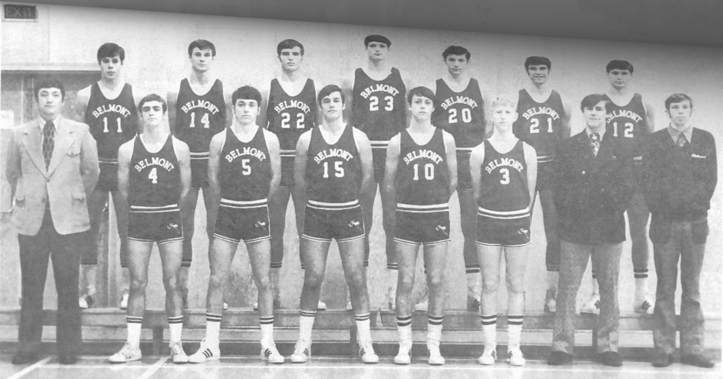
Back Row Left to Right: John Hunter, Scott Allen, Rick Denman, Lee Edmondson, Mike Dibblee, Jim Merz, Clive Haas
Front Row Left to Right: Coach Wally Russell, Jim Kupiak, Don Salmons, Jack Munch, Ken Lidstone, Gary Davidson, Rick Sylvester, Bill Young

