1959-60 Senior Boys’ Basketball Team
The 1959-60 Braves were the top Belmont basketball team in the school’s young history. Under the capable guidance of co-coaches Mr. Parrot and Mr. Banks, the boys developed into one of the strongest teams on the Island. The Braves finished fourth in league play, with the highlight of the season being a tense match against their rivals from Vic High, one of the powerhouse teams in the province. The Totems came into the Belmont gym undefeated, and in front of an enthusiastic home crowd, the Braves knocked off their rivals in a thrilling one point victory, as Mel Spotswood sank the winning free throws with only a few seconds left. Vic High didn’t lose another game the entire season and captured the BC Championship trophy. The Braves could take pride in the fact that they were the only team to defeat the provincial champions that year.
The Belmont boys turned in some strong performances at the Lower Island tournament. After an opening victory against Mt. View, a 33-22 loss to Oak Bay took them out of title contention. They rebounded to win the next three games of the tournament to end up in 4th place, which earned them a spot in the Vancouver Island tournament. Although the Belmont boys came up a little short in their quest to qualify for the provincial tournament, overall they were very satisfied with their season.
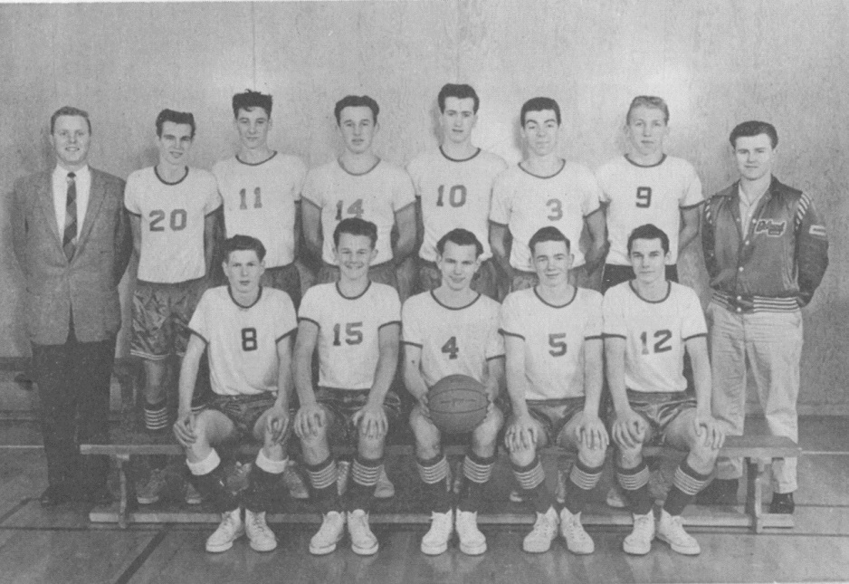
Back Row: Mr. Banks, Bob Eddy, Wayne Allen, Russ Rhode, Bill Spotswood, Ricky Floyd, Ray Mickelson, Trev Mathias
Front Row: John Allen, Gary Smith, Mel Spotswood, Dale Keown, Rod Kilduff

