1957-58 Track and Field Team
The 1957-58 track and field team captured Belmont’s first ever Lower Island championship held at Victoria High School May 24th, 1958. The meet featured a variety of events in both the senior and junior age groups. Belmont’s population was not as large as some of the other “in-town” schools, but Archie Stephenson’s focus on athletics through the house system meant that all students experienced regular athletic competition as part of their regular school activities.
Belmont athletes who recorded top three performances, as reported in the sports section of the 1958 Kee-Yu yearbook, are listed below.
First Place Finishers:
Cecilia Hall: junior girls high jump and junior girls hop, step and jump
B. Carlow: senior girls high jump
Cliff Kilduff: junior boys high jump
R. Rhode: junior boys shotput
B. Calloway: senior boys 440
Geoff Hett: senior boys mile
Don Robson: senior boys broad jump and senior boys hop, step and jump
Junior boys relay
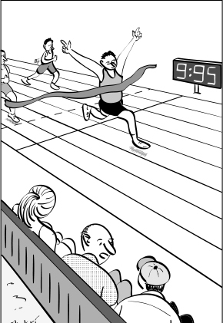
Second Place Finishers:

R. Speers: junior girls 50 yard dash, junior girls 100 yard dash
S. Hall: junior girls broad jump
J. Carlow: senior girls 60 yard dash
B. Paillett: junior boys high jump
D. Anderson: junior boys shotput
Don Robson: senior boys 100 yard dash
Geoff Hett: senior boys 880

Third Place Finishers:

S. Reece: junior girls 100 yard dash and junior girls high jump
Mel Spotswood: junior boys 880
Rod Kilduff: junior boys hop, step and jump
B. Paillett: junior boys high jump
John Batchellor: senior boys 220
B. Calloway: senior boys mile

